# Chapter 2: Financial Math

## Section 2.4 Loan Payments

In the last section, you learned about savings plans. In this section, you will learn about conventional loans (also called amortized loans or installment loans). Examples include student loans, car loans and home mortgages. These techniques do not apply to payday loans, add-on loans, or other loan types where the interest is calculated up front. In this section we will also briefly cover credit cards. There is a more thorough chapter on credit cards available as an optional chapter.

# Installment Loans

Installment loans are also called **amortized loans**. They are designed so that the payment amount remains the same over the life (term) of the loan. In order for that amount to remain constant, the amount of money going towards paying the **principal** (amount owed) and towards the **interest** will vary. At the beginning of the loan, the amount owed is the largest. So, at the beginning the amount of interest charged will also be the largest. As the loan gets repaid the amount owed is reduced and therefore the interest is reduced. Therefore, at the beginning of an installment loan payments go mostly towards the interest, towards the end the payments are going mostly towards the principal.   
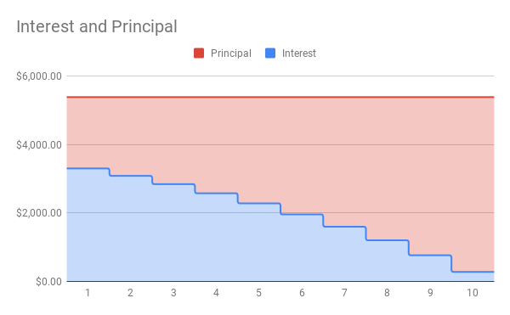

This is a graph of the interest and principal paid on a loan of $34,000 at 10% APR. Each year $5391.72 was paid in total. In the first year, $3,3305.92 was applied to the interest and $2085.80 was applied to the principal. In the last year of the loan, only $281.04 was applied to the interest and $5,110.68 was applied to the principal. Over 5 years, a total of $53,917.2 was paid for a loan of $34,000.

### Loan Formulas

In a savings plan, you start with nothing, put money into an account once or on a regular basis, and have a larger balance at the end. Loans work in reverse. You start with a balance owed, make payments and the future value is zero when the loan is paid off.

We will continue to use the same spreadsheet formulas. The ones that are most useful for loans are =PV and =PMT. We will look at how the inputs change for a loan.

Spreadsheet Formulas

=PV(rate per period, number of periods, payment amount, future value)

=PMT(rate per period, number of periods, present value, future value)

*rate per period* is the interest rate per compounding period, *r/n*

*number of periods* is the total number of periods, *n*t*

*payment amount* is the amount of regular payments, *d*

*present value* is the amount deposited or principal, *P*

*future value* is the amount you want in the future, *0 for a loan*

These two formulas correspond to the formulas below. The formula for loans is derived in a similar way that we did for savings plans, but notice they have negative exponents. The details are omitted here.

Loan Formulas

 or 

*P* is the balance in the account at the beginning (the principal, or amount of the loan).

*d* is your loan payment (your monthly payment, annual payment, etc.)

*r* is the annual interest rate in decimal form

*n* is the number of compounding periods in one year

*t* is the length of the loan, in years

Like before, the compounding frequency is not always explicitly given, but is determined by how often you make payments

Example 1:

Teresa wants to buy a car that costs $15,000. She has $3000 saved for the car and plans to finance the rest. She found a 3-year loan at 2.75% APR and a 5-year loan at 4%. How much will her monthly car payment be for each loan and how do these loans compare to each other.

To use a spreadsheet, we use the =PMT formula. For a loan, the loan amount is the present value and the future value is 0, indicating that the loan will be paid off. Teresa is making a down payment, so we also need to subtract that from the cost of the car to find the loan amount:

$15,000 – $3,000 = $12,000

Her loan amount is $12,000. For the 3-year loan at 2.75% APR, we enter:

=PMT(0.0275/12, 12*3, 12000, 0)

=$347.65

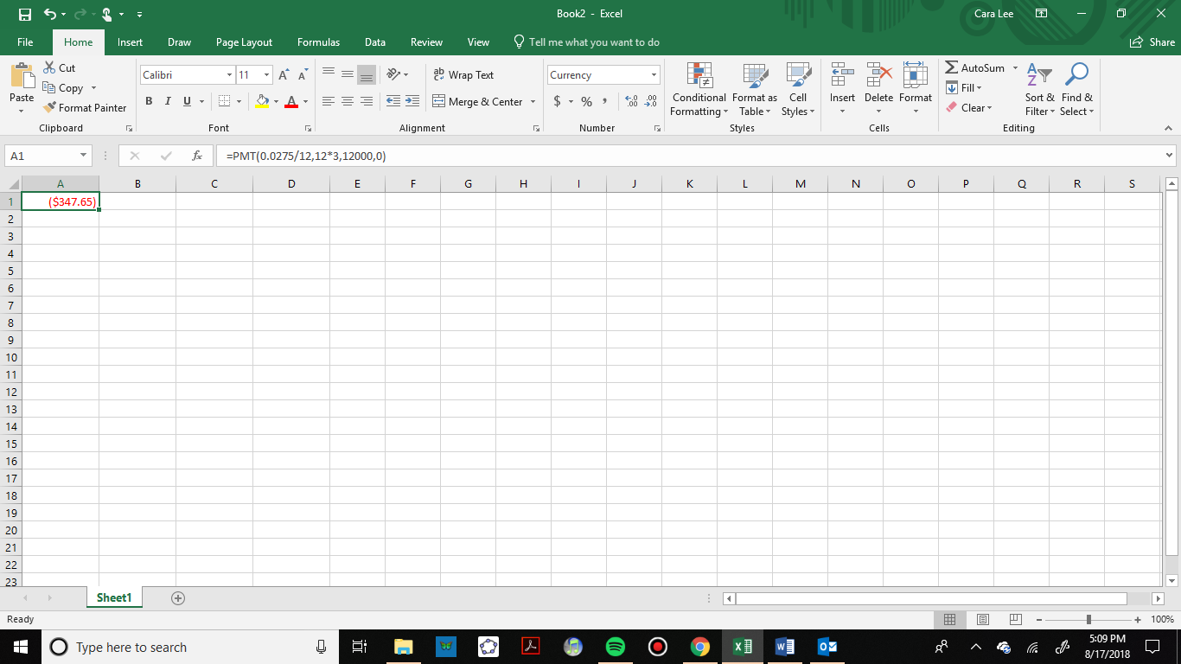

For the formula, we use the one solved for *d*:

*r* = .0275 2.75% annual rate  
*n* = 12 monthly payments

*t =* 3 3 years

*P* = 12000 Since she can pay $3,000 of the $15,000



Teresa’s car payment would be $347.65.

Now for the 5-year loan at 4% APR, we enter:

=PMT(0.04/12, 12*5, 12000, 0)

=$221.00

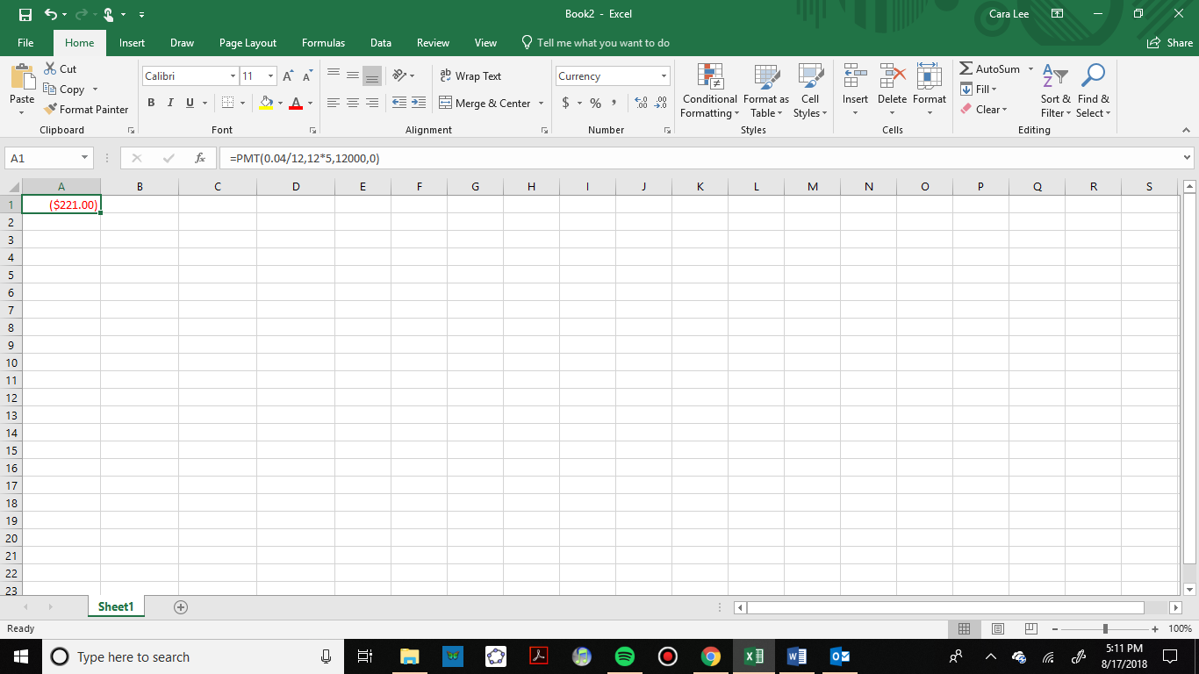

To use the formula, we have:

*r* = .04 4% annual rate  
*n* = 12 monthly payments

*t =* 5 5 years

*P* = 12000 the loan amount

  
Now let’s compare the loans by finding out how much Teresa would pay in interest for each loan.

For the 3-year loan at 2.75% APR, her payments would total:



Her interest would be $515.40.

For the 5-year loan at 4% APR, her payments would total:



Her interest would be $1,260.00.

There are two main differences between these two loans: the monthly payments and the total paid over the life of the loans. The first loan has a higher monthly payment by $126.65 per month. However, she would pay $744.60 less in interest.

In addition to loan payments, we can calculate the amount of loan we can afford given a monthly payment. Let’s look at that in the next example.

Example 2:

You can afford $200 per month as a car payment. If you can get an auto loan at 3% interest for 60 months (5 years), how expensive of a car can you afford? In other words, what amount loan can you pay off with $200 per month?

To use a spreadsheet for this problem, we use the =PV formula because we want to know the present value, which is the value of the loan right now. We enter

=PV(0.03/12, 12*5, 200,0)

=$11,130.47.

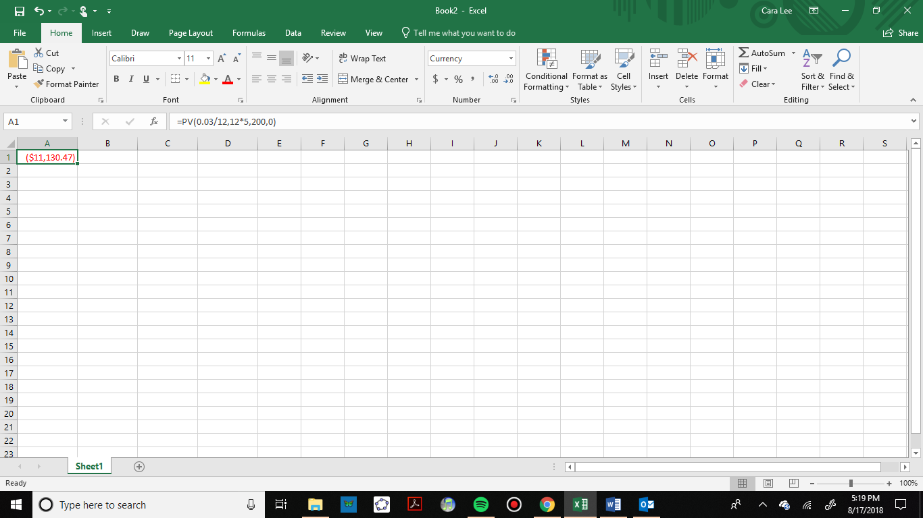

To use a formula, we are looking for *P*, the starting amount of the loan.

*d* = $200 the monthly loan payment

*r* = 0.03 3% annual rate

*n* = 12 since we’re doing monthly payments, we’ll compound monthly

*t* = 5 since we’re making monthly payments for 5 years



You can afford a maximum loan of $11,130.47. If you have a down payment you can add that to get the value of the car you can buy. If there are any closing costs for the loan you also need to take that into consideration.

To find the amount of interest you will pay for this loan, calculate the total of all your payments.



Then take the difference between the total payments and the loan amount.

.

In this case, you would be paying $869.53 in interest.

So far, we have looked at car loans. Student loans and home mortgages are calculated in the same way. Here is an example of a mortgage payment.

Example 3:

You want to take out a $140,000 mortgage (home loan). The interest rate on the loan is 6%, and the loan is for 30 years. How much will your monthly payments be? What percentage of your total payments will go towards interest?

To use a spreadsheet for this problem, we use the =PMT formula because we want to know the payment amount. The amount of the loan is the present value and to pay off the loan the future value is 0. We enter

=PMT(0.06/12, 12*30, 140000,0)

=$839.37.

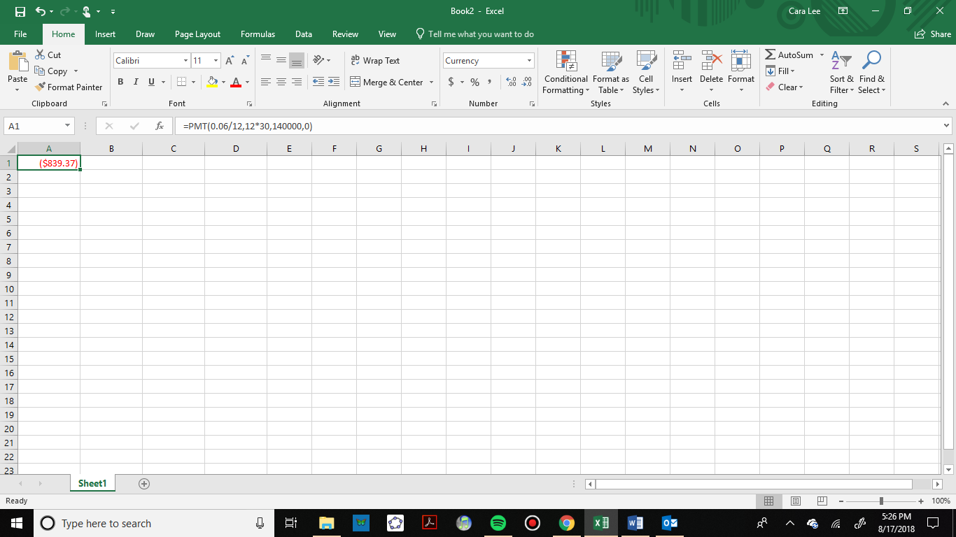

To use the formula, we have:

*r* = 0.06 6% annual rate

*n* = 12 since we’re paying monthly

*t* = 30 30 years

*P* = $140,000 the starting loan amount

In this case, we’re going to use the equation that is solved for *d.*



You would make payments of $839.37 per month for 30 years.

To find out what percentage of the total will go towards interest, we need to total up all of the payments.



Then take the difference between the total payments and the loan amount.

.

In this case, you would be paying $162,173.20 in interest over the life of the loan. To find the percentage, we divide the interest by the total amount paid.

or 53.7%

About 53.7% of the total is being paid towards interest.

### Remaining Loan Balance

With loans, it is often desirable to determine what the remaining loan balance will be after some number of years. For example, if you purchase a home and plan to sell it in five years, you might want to know how much of the loan balance you will have paid off and how much you will have to pay from the sale.

To determine the remaining loan balance after some number of years, we first need to calculate the payment amount, if we don’t already know it. Remember that only a portion of your loan payments go towards the loan balance; a portion is going to go towards interest. For example, if your payments were $1,000 a month, after a year you will *not* have paid off $12,000 of the loan balance.

To determine the remaining loan balance, we can think “how much loan will these loan payments be able to pay off in the remaining time on the loan?”

Example 4:

If a 30-year mortgage at a 6% interest rate has payments of $1,000 a month, what will the loan balance be in 5 years?

To determine this, we need to think backwards. We are looking for the amount of the loan that can be paid off by $1,000 per month in the remaining 25 years. In other words, we’re looking for *P* when:

*d* = $1,000 the monthly loan payment

*r* = 0.06 6% annual rate

*n* = 12 since we’re doing monthly payments, we’ll compound monthly

*t* = 25 since we’d be making monthly payments for 25 more years

To use a spreadsheet for this problem, we use the =PV formula because we want to know what the present value would be at the time you want to sell in 5 years. We enter:

=PV(0.06/12, 12*25, 1000,0)

=$155,206.86.

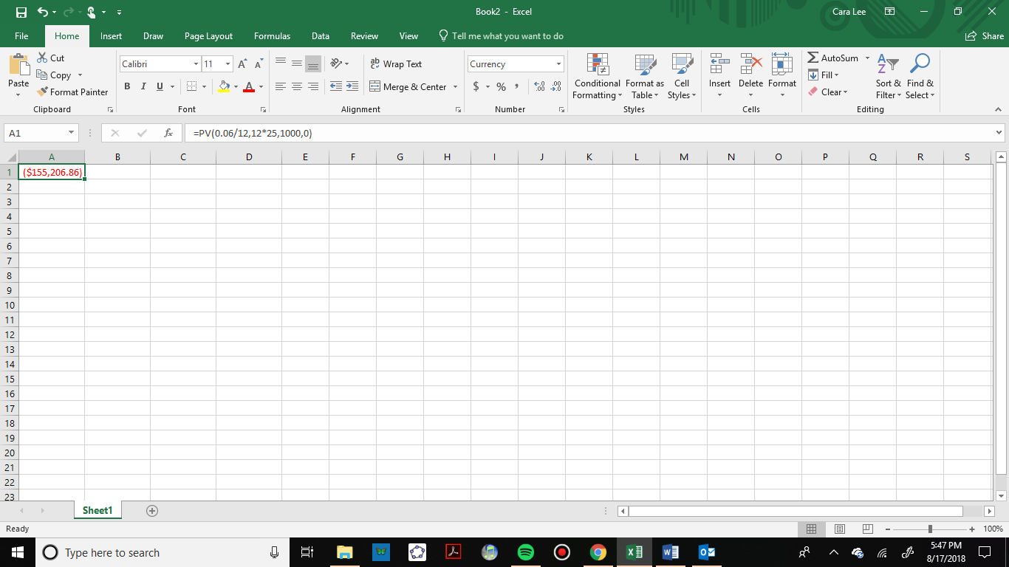

To check this with the formula we have:



The loan balance with 25 years remaining on the loan will be $155,206.86

Sometimes answering remaining balance questions requires two steps, both of which we have done in this section:

1. Calculate the monthly payment on the loan
2. Calculate the remaining loan balance based on the *remaining time* on the loan

### Credit Cards

Credit cards are useful to many people. They can be used to build a credit score, as a short-term loan and as an alternative to physical cash. It is highly advisable to fully pay off a credit card each month because the interest rates are much higher than the conventional installment loan we discussed earlier. There can also many expensive fees applied when carrying a balance. Because of these higher rates, it can be very easy to get into a lot of debt quickly.

Credit cards are a common source of loan money, and therefore a common source of debt which must be repaid.  There are much fewer and lower barriers to obtaining and using a credit card than there are to obtaining, for example, a mortgage.  As such, there are some drawbacks both in terms of typically higher interest rates, as well as some structural differences.

Example 5:

Bilqis gets a credit card, with 17.99% APR compounding daily.  She uses the card to buy a $900 plane ticket.  She does not make any payments during the interest-free grace period.  Her first payment is due 35 days after the grace period ended.  Following the fine print in the credit card agreement, the minimum payment is calculated to be 1% of the outstanding balance after applying the APR; or $25, whichever is larger. What is her outstanding balance? What is her minimum payment? What is her new balance?

 ≈$915.66

The spreadsheet formula for this computation is =fv(0.1799/365,35,0,900).

Her outstanding balance is $915.66.

“One percentage point more than the APR of this outstanding balance” would be $915.66(0.01+0.1799)≈$173.88.

$173.88 is larger than $25. So, Bilqis’s first payment must be at least $173.88 if she wants to avoid any penalties.

That payment will be used to decrease the balance.



So, her new balance will be $741.78.

Example 6:   
Bilqis continues to only make the minimum payments. How long will it take her to pay off the plane ticket? How much will she pay for this $900 plane ticket?

A spreadsheet is a great way to organize this process.

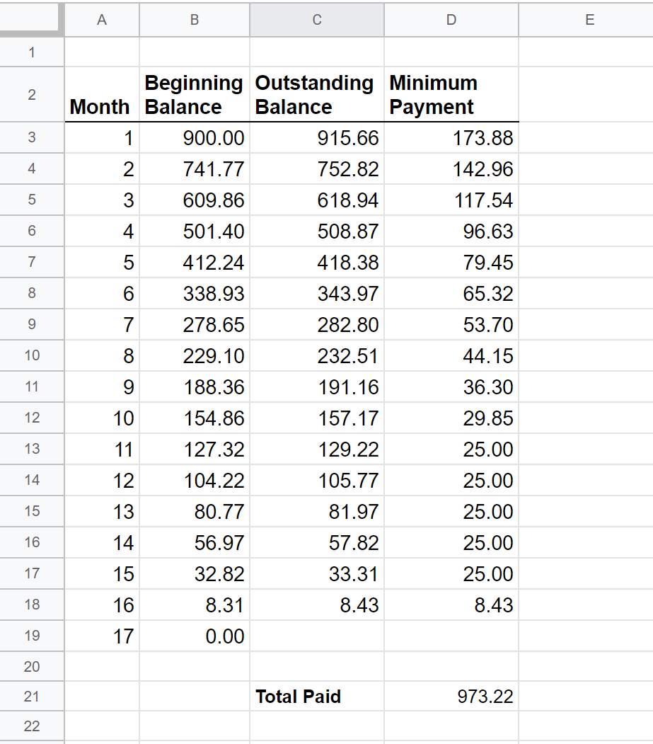

Formulas Used: =C3-D3, =B4*(1+0.1799/365)^30 or =fv(0.1799/365,30,0,B4), =C4*(0.01+0.1799), =sum(D3:D19)

It will take Bilqis 16 months to pay of the $900 plane ticket. She paid a total of $978.06.

### Summary of Spreadsheet Formulas

Here are all the spreadsheet formulas from this chapter so far together so you can see the similarities and differences.

Spreadsheet Formulas

=principal+principal*rate*time

=FV(rate per period, number of periods, payment amount, present value)

=principal*EXP(yearly rate*years)

=PV(rate per period, number of periods, payment amount, future value)

=PMT(rate per period, number of periods, present value, future value)

=EFFECT(stated rate, number of compounding periods per year)

*rate per period* is the interest rate per compounding period, *r/n*

*number of periods* is the total number of periods, *n*t*

*payment amount* is the amount of regular payments, *d*

*present value* is the amount deposited or principal, *P*

*future value* is the amount you want in the future, *0 for a loan*

#### When to use the formulas: What is the question asking?

* Find a payment: =PMT
* Find the effective rate or compare accounts: =EFFECT
* How much do you need to deposit now, what loan amount can you afford, or remaining loan balance: =PV
* What will the account balance be in the future?
  + Simple interest: =principal+principal*rate*time
  + Compound interest (except continuous): =FV
  + Continuously compounded interest: principal*EXP(rate*years)

### Summary of Mathematical Formulas

Mathematical Formulas

Simple Interest  

Compound Interest  or 

Continuously Compounded

 or 

Savings Plans  or 

Loans  or 

*P* is the principal, starting amount, or present value

*d* is your loan payment (your monthly payment, annual payment, etc.)

*r* is the annual interest rate in decimal form

*n* is the number of compounding periods in one year

*t* is the length of the loan, in years

*A* is theend amount or future value

If the compounding frequency is not always explicitly given, it is determined by how often you make payments

#### When to use the formulas: What is the question asking?

* Find a payment
  + Savings payment: savings plan equation (positive exponent) solved for *d*
  + Loan payment: loan equation (negative exponent) solved for *d*
* How much do you need to deposit now?
  + Compound interest (except continuous): compound interest formulas solved for *P*
  + Continuously compounded: the formula with *e* solved for *P*
* What loan amount can you afford, or remaining loan balance: loan formula solved for *P*
* What will the account balance be in the future?
  + One-time deposit:
    - Simple interest: simple interest formula
    - Compound interest (except continuous): compound interest formula solved for *A*
    - Continuously compounded interest: the formula with *e* in it, solved for *A*
  + Regular payments: Savings plan formula solved for *A*

Remember, the most important part of answering any kind of question, money or otherwise, is first to correctly identify what the question is really asking, and to determine what approach will best allow you to solve the problem. After practicing with the exercises from this section, you can test yourself with the cumulative chapter 2 exercises.